**Relevant Django Features and Documentation**

1. Admin and user account and authorization features are supported by an automatic interface.

<https://docs.djangoproject.com/en/4.1/ref/contrib/admin/>

https://docs.djangoproject.com/en/4.1/topics/auth/

1. Our sponsor indicated the need to scale to over 400 stores within the next two years; Django is easily able to support this with their cache framework. Django also provides ‘Dummy caching’ specifically for development environments.

<https://docs.djangoproject.com/en/4.1/topics/cache/>

1. Models provide an easy way to access and manipulate fields of our database.

<https://docs.djangoproject.com/en/4.1/topics/db/models/>

1. HTML forms in Django allow us to manage the app I/O handled by Django’s template interfaces that simplify and automate vast portions of the work.

<https://docs.djangoproject.com/en/4.1/topics/forms/>

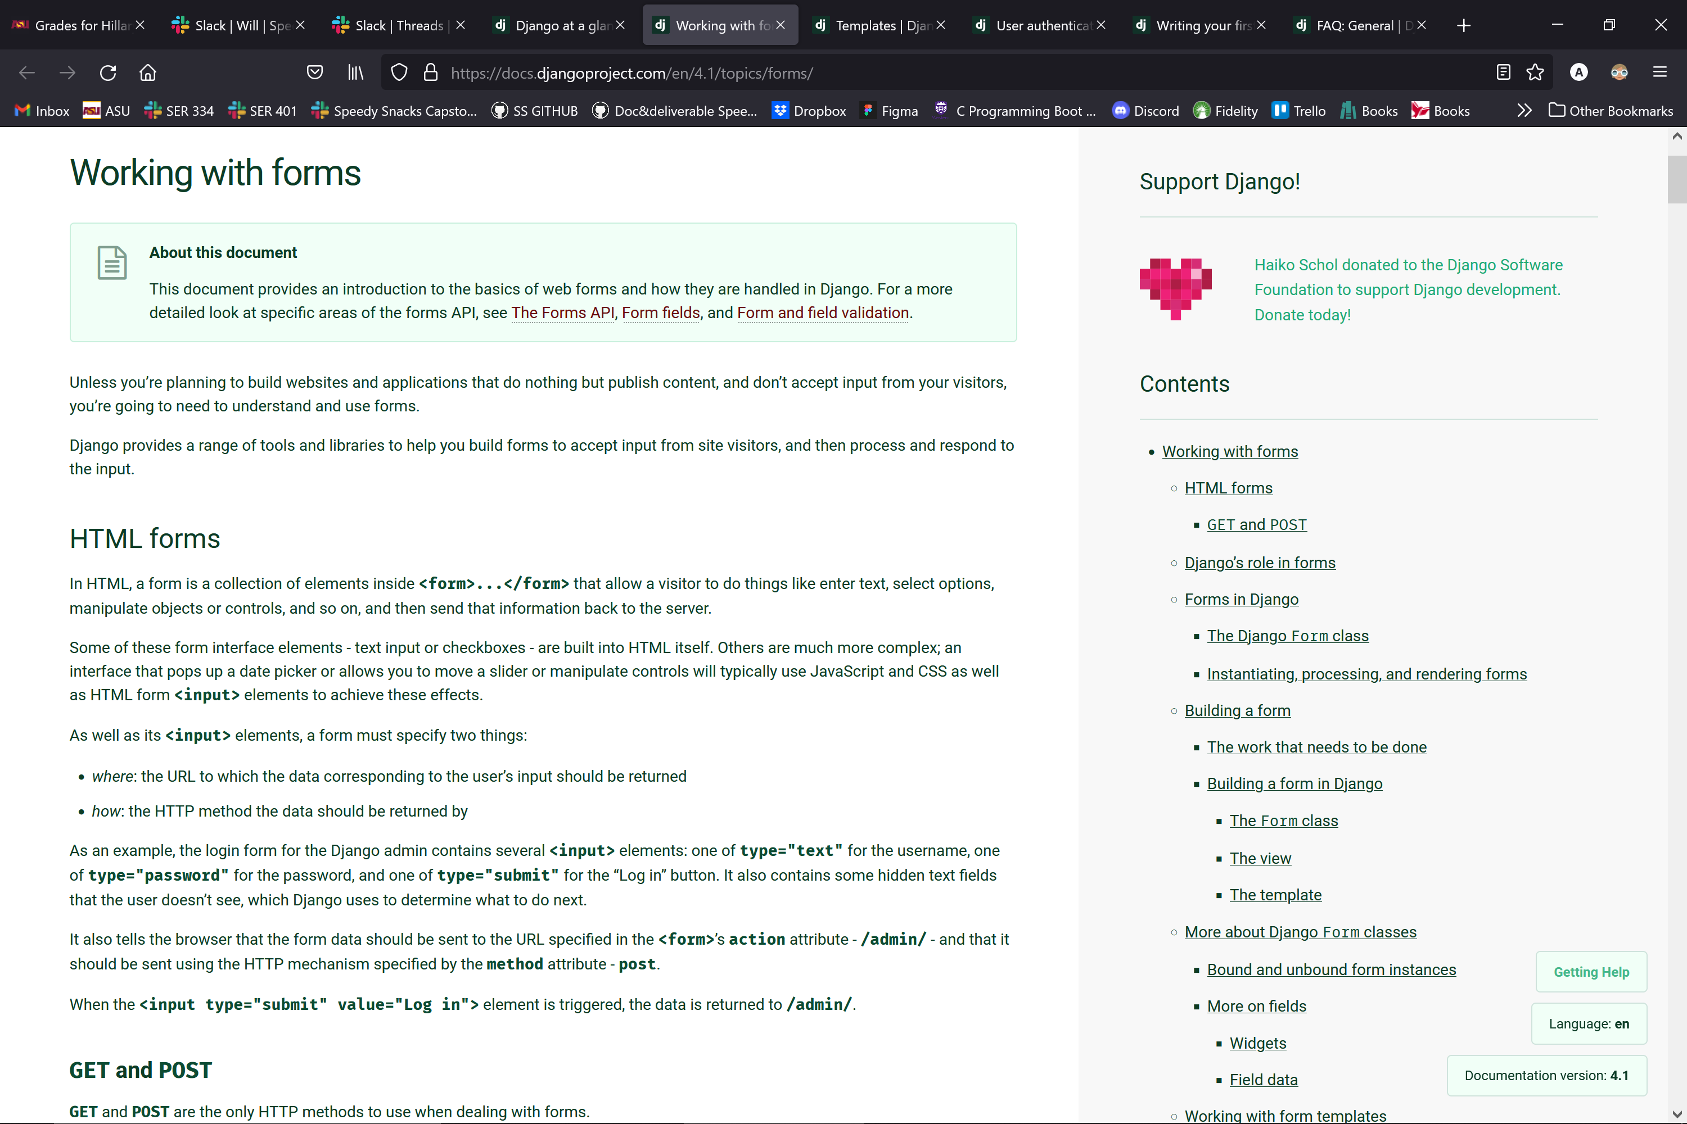

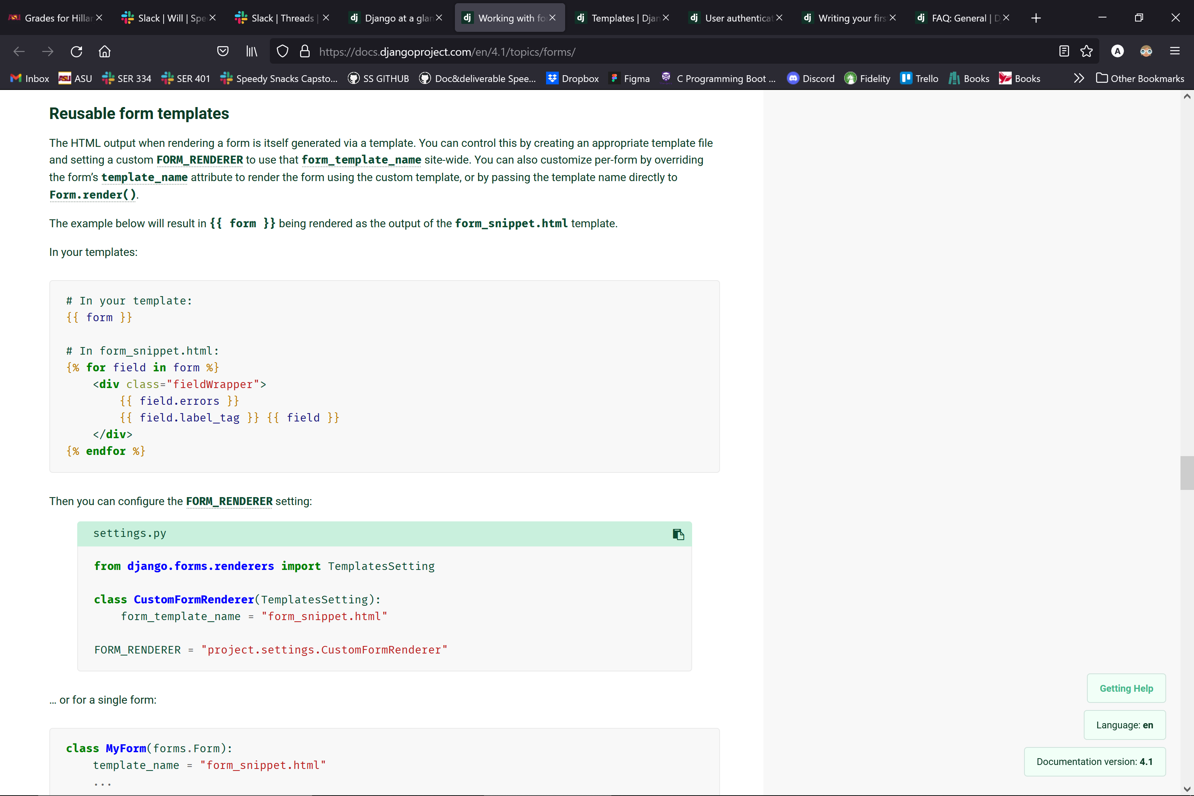

1. Templates can provide a way to dynamically generate HTML using variables and tags that can output values and content, serve as control structure, grab content from a database or enable access to other temlate tags.

<https://docs.djangoproject.com/en/4.1/topics/templates/>

1. Django provides a DB abstraction API to manipulate objects in the data model.

https://docs.djangoproject.com/en/4.1/topics/db/queries/

1. Django has built-in translation functionality. Our sponsor indicated that multiple language support would provide user value to the fullfillment partners.

<https://docs.djangoproject.com/en/4.1/topics/i18n/translation/>